How Large is a Micron?

Which Vectapure 360 Filtration system is right for you?

Model  Reduces | Coarse sand | Sediment | Chlorine | Odor | VOC  Volatile organic Compound | Lead | Bacteria/Virus | Arsenic | Calcium | Magnesium | Lead, Heavy Metals
Single Stage | 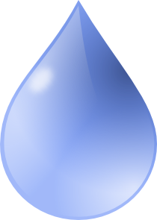 |  |  |  | X | X | X | X | X | X | X
Dual Stage |  |  |  |  |  | X | X | X | X | X | X
Ultra-  Filtration |  |  |  |  |  |  |  | X | X | X | X
Reverse
Osmosis

